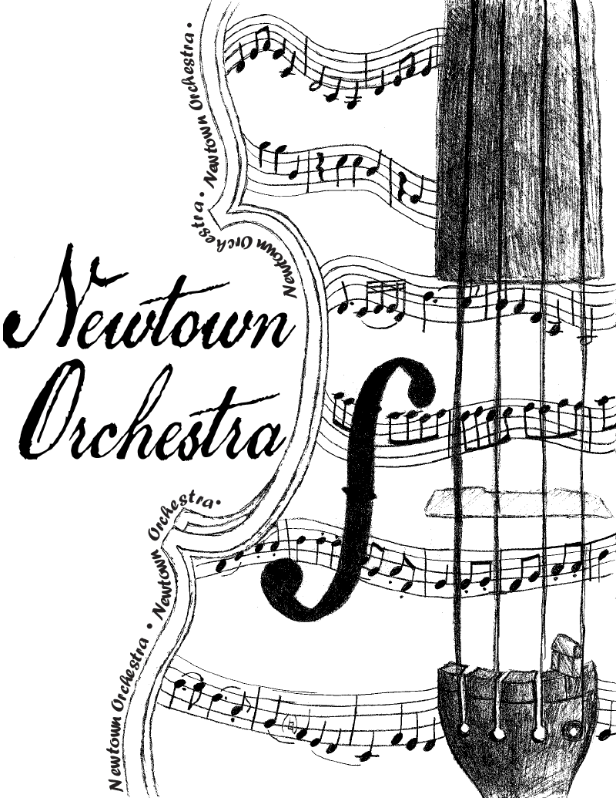

Newtown Orchestra Parents Group
Scholarship Application 2019

The Newtown Orchestra Parents Group (NOPG) Scholarship is available to any senior currently enrolled in the Newtown High School Orchestra. Scholarship selection is based upon past involvement in the Orchestral Program, as well as the submitted application. Scholarship(s) will be awarded to deserving seniors at the NHS Orchestra Concert on May 21, 2019.

Please type your answers to each question on a separate sheet of paper. Please label the paper with your name, address, email address and phone number. (Personal information will be hidden for confidentiality and fairness during the selection process).
.

- List your activities within the NHS Orchestra, Music and Drama Programs. Please include dates of participation (freshman year, sophomore year, etc).

- List other music related activities that you have participated in outside of school during the past four years (private lessons, recitals, ensembles, music festivals, etc). Please include dates of participation.

- What other non-music activities have you participated in during your high school career (clubs, sports, volunteer work, jobs, internships, etc)? Please include dates of participation.

- Describe what your involvement in the NHS Orchestra Program has meant to you, and how music will play a role in your post-high school life.

The completed scholarship application must be returned to Mrs. Latowicki in the Career Center by April 26, 2019. Any questions can be directed to neworchparents@gmail.com.

