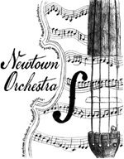
Newtown Orchestra Merchandise Order Form

Student Name: _______________________________________

School: RIS NMS NHS

Parent email: ________________________________________

Item Price Qty Total $
T-shirt, short sleeved | Adult S-M-L-XL | $10
T-shirt, long sleeved | Adult S-M-L-XL | $15
Crew sweatshirt | Adult S-M-L-XL | $20
Hooded sweatshirt | Adult S-M-L-XL | $30
Tote bag |  | $10
Car magnet | ORCH or violin | $5
Instrument case tag |  | $3
TOTAL

Total Amount: $__________ Payment method: Cash Check

Return order form and payment to your Orchestra teacher. Make checks payable to NHS Activity Fund. Photos of all items are on the NOPG website nopg.weebly.com. If any questions, contact us at neworchparents@gmail.com.

Thank you for your ongoing support of Newtown Orchestra! Rev. 7/19

